# General Advice

* Add units to your final answers (eg, metres for vectors questions).
* “Fully justify to your answer” would mean go ahead and whip out the definition (like for bipartite).
* More often, try and show things are the case with maths rather than words (eg, matrix addition).

# Discrete

## DA - Graphs

* Pay careful attention to keywords and their definitions (eg, a simple graph doesn’t necessarily have to be connected).
* For a graph to have the same number of edges in a Hamiltonian cycle as the number of edges in an Eulerian trail, it must be 3 edges.
  + Since the number of edges in a Hamiltonian cycle equals the number of vertices and the number of edges in an Eulerian trail is n(n - 1)/2. Both these sequences have 3 in them.
* Remember to include the infinite face.

### Planar and non-Planar Graphs by Euler’s Formula

* You can use 2E ≥ 3F alongside Euler’s formula to show a graph is nonplanar.
  + This comes from the fact that all faces are made up of 3 edges and when counting all the faces, each edge is counted at most twice (as an edge sits in at most 2 faces.)
  + An example is shown below:

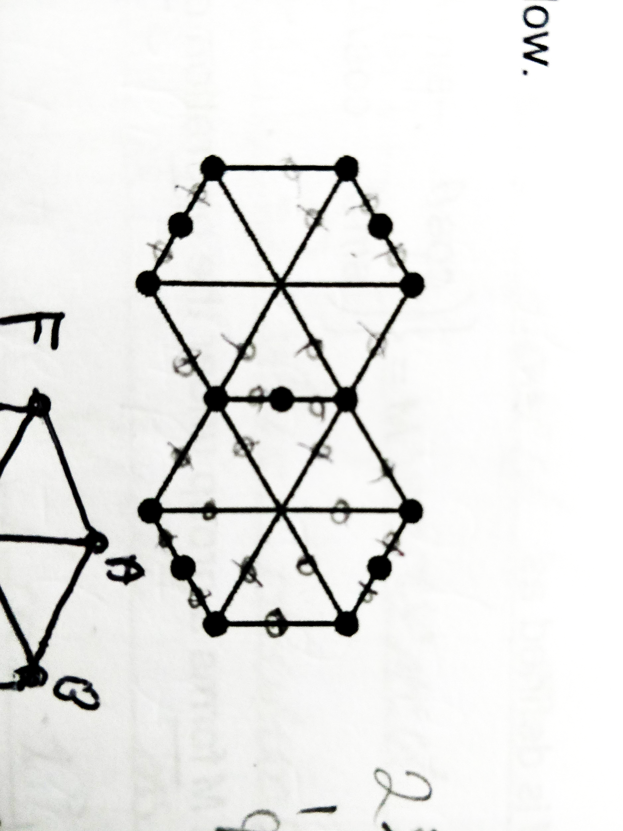

1. Let’s assume that the graph is planer so by Euler’s Formula: V + F - E = 2.
2. The graph has 15 vertices and 22 edges so must have 9 faces.
3. The shortest cycle in the graph has 5 edges so each face must have at least 5 edges. And each edge forms a boundary between 2 adjacent faces so 2E ≥ 5F.
4. However, 2E = 44 and 5F = 45 which is a contradiction thus N must be nonplanar.

* Don’t sweat it if you’re off by 1 or 2 for the shortest route in Chinese Postman, they usually accept at least 4 of the 6 correct. As long as you get the same answer.

*The below isn’t required but it is interesting.*

### Pigeonhole Principle

* If you must store n pigeons in k pigeonholes where n > k then at least 1 pigeonhole contains more than 1 pigeon.
* For handshakes, you can have: 0, 1, 2, 3, …, n - 1. Yet, if someone shakes no hands, no one can shake n - 1 hands and if someone shakes all hands, no one can shake 0 hands. Thus we have n people with n - 1 choices thus 2 people will shake the same number of hands.

## DB - Networks

* When making an edge mandatory in a MST, add the edge, and remove the largest arc that forms a cycle.
* Be sure to expand any shortened path someone takes (remember, they’re using indirect roots).

## DC - Network flows

* State “by the maximum-flow minimum-cut theorem” when using it. Especially for “fully justify your answer”.

## DD - Linear programming

* Under Simplex, state that you stopped because “the objective row is entirely non-negative.”
* Remember to…
  + Declare the lower limits (e.g., x, y, z ≥ 0) if undefined.
  + Label the feasible region.
  + Use simultaneous equations to work out the exact amount.
  + Write “the number of … produced.”
* If it asks to “work out the profit” then take into account cost.
* A linear programming problem requiring integer solutions may require comparing the local integer coordinates to an optimal vertex.
* Double check your simplex tableau with the constraints.

### Objective Line

P = 3x + y ⇒ y = -3x + P

* And thus draw a gradient of -3 using the change in height and width idea.

## DE - Critical path analysis

* Ensure you perform the backwards pass properly - minus the duration from the late time ∵ if you think about it, it’s the latest an activity can start without delaying the project.
* When drawing cascade diagrams, ensure there’s no gaps along the y-axis to ensure all the workers have been used.
* Add a start and an end to the activity network. You gotta make sure the final activites end at the same time.
* Consider carefully the effect on all activities in the critical path.

## DF - Game theory for zero-sum games

* Remember that you will have to keep switching perspectives.
* The point of intersection is the maximum point where an outcome is **GUARANTEED**.
* When concluding an optimal mixed strategy, mention which strategies and with what probabilites.
* Show that the game requires an optimal mixed strategy by showing there is no stable solution.
* The assumption made when a player uses an optimal mixed strategy is that the other does too.
* Always check for dominance and mention it at the beginning of any problem (where there is or isn’t any).

## DG - Binary operations and group theory

* You cannot have two identity elements (e.g., one for a * b and another for b * a).
  + This is because… Suppose e and f are both identity elements then e * f = e where e is the identity element and e * f = f where f is the identity element. Thus e = f.
* Remember the mudolo symbol can be written as 7 +8 5 = 4 and 7 x4 5 = 3.
* Use Cayley Tables a lot more often, they can be very useful. Especially for finding inverses:

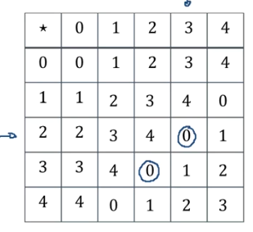

* Be sure to write a conclusion about it being a group.
* Subgroup must also fit al the conditions for a group.
* If every row and every column has an identity element it means each element has an inverse.
* Every row and every column must contain all group elements and no duplicates (this can be proved easily).

# Statistics

* You can use conditional probability here too, remember that!
* Be specific and state the population when you can (ie, level of purity and mass of crisps).
* State the mean for a Poisson Distribution because why not.
* “Fail to reject H0”.

## SA - DRVs and expectation

* Use the fact that for the mean and variance of uniform distribution (1, 2, 3, ...) can related by a linear relationship.
* Write the formula for expected value to ensure you work it out correctly.

## SB & SC - Poisson distribution & type I/II errors

* You cannot conclude a test with certainty, “some certainty” is better.
* Keep in mind that the hypotheses should be made about parameters (for chi-squared tests, it’s a statement).
* For a Type I error, you won’t get exactly 5% as Poisson is discrete, look for the p-value of the critical value (perhaps 4.6%).
* Careful with parameters lambda and mu, use lambda for tests with Poisson.
* No queues in Poisson (eg, on the motorway) for independent.

## SD - CRVs

* For working out cumulative distribution functions by integration, use + a, + b, + c after each integrated part and equate this from the start to find all of them. Be careful of gaps.

## SE - Chi tests for association

* Use fractions more often in this so you won’t have to type in as many numbers. Don’t round since rounding each value can drastically affect your answer.
* Make a plausible observation for any association (if there aren’t any, state the observed and expected frequencies are sufficiently close).
* The assumption made about the sample data for a chi-squared test to be valid is that a random sample is used.

## SF - Exponential distribution

* Try and spot λe-λx.
* Exponential models waiting time between Poisson events whereas Poisson is the number of exponential events in unit time. Lambda = 1 / (waiting time between poisson events).

## SG & SH - t-distribution & confidence intervals

* Recognise when a t-test is being used and use inverse t, if necessary.
* Recognise when a t-test is being used. Use inverse t-distribution from the tables.
* A larger sample means a sample variance closer to the population variance.
* When it says to “fully justify your answer” then say a t-test / t-distribution was used as the n < 30 **and** population variance is unknown.
* Always check the tables for the t-values, don’t end up using a z-distribution.

use constructed and/or given confidence intervals, identifying that:

• if a confidence interval contains a given value then there is insufficient evidence that the

population mean differs from this value

• if a confidence interval is completely below a given value then there is significant evidence the

population mean is less than the given value

• if a confidence interval is completely above a given value then there is significant evidence the

population mean is greater than the given value

• if the confidence intervals overlap then there is insufficient evidence of a difference between

the population means from which the samples were taken

• if the confidence intervals do not overlap and the confidence interval for μA is below the

confidence interval for μB then there is significant evidence of a difference between the

population means from which the samples were taken and that μB > μA